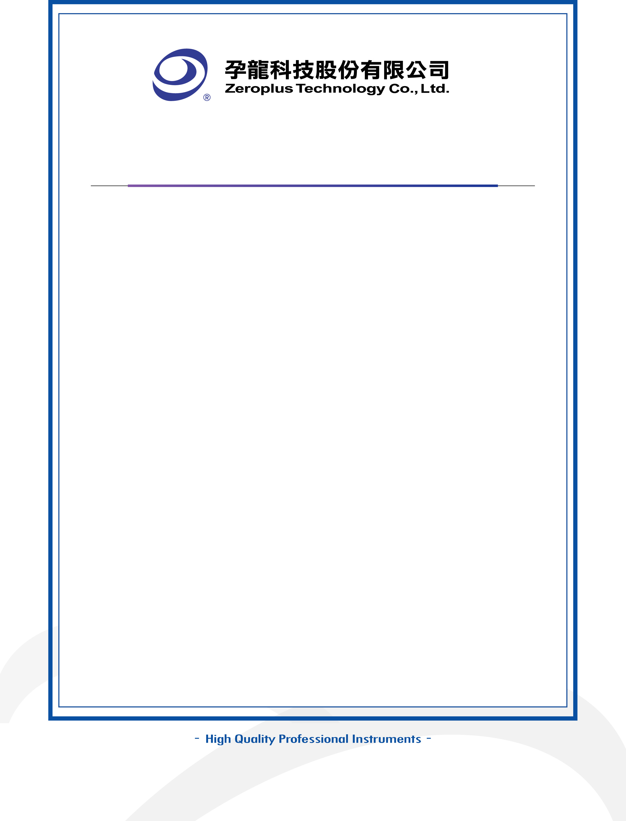

Authorized Agreement

Module Name : Protocol Analyzer of _________ (Module Name)
Decoding Module
Designer Name:
I hereby grant a free license to Zeroplus Technology and
duplicate, translate, transmit publicly.

Licensor: (Signature):
Title of Module:
Tel.:
Date: CN- __ (Day) __ (Month), __ (Year)

Licensee: Zeroplus Technology Co., Ltd.
Address: 3F., No.121, Jian Ba Rd., Chung Ho City, Taipei County, Taiwan
Tel.: 02-6620-2225
Date: __ (Day) __ (Month), __ (Year)

